

**PROPOSAL TO**



For

Implementation Robotic Process Automation

Submitted by:

Kranti Batchala

Vice President, Enterprise Solutions

Email: kkbatchala@netlink.com

Mobile: +91-9589277912

**Table of Contents**

1. COVER LETTER/EXECUTIVE SUMMARY 2
2. NETLINK PROFILE 4
3. PROJECT GOVERNANCE 5
4. PROJECT IMPLEMENTATION APPROACH 6

Proposed Architectur**e 7**

1. UIPATH PRODUCT DETAILS 7
2. DELIVERY/IMPLEMENTATION METHODOLOGY & APPROACH 8
3. SCOPE OF WORK 11

OverVIEW 12

BOT FLOWCHART 13

DETAIL PROCESS DETAILS 13

Efforts Estimation for RPA 19

Project Schedule / Timelines 20

Criteria for considering the development done for a process 21

Project Team 21

Assumption 21

1. SUPPORT 22

Hours of Operation 22

Average and Guaranteed Response Time 22

1. TRAINING PROCESS 23

Guiding Training Philosophy 23

Identification of Client Training Gaps/Needs 23

Forms/Methods of Training Utilized 24

Availability of Trainers / Training Material 24

Updates to Training Materials 24

**1. Cover Letter/Executive Summary**

Aug 21, 2022

Noida Power Company Limited (NPCL)

Subject: Response to Request for Proposal for Robotic Process Automation

Dear Mr. Ramesh Arora,

Netlink appreciates the opportunity to bid for the Noida Power Company Limited (NPCL) Robotic Process Automation RFP. Netlink has proven track record in implementing IT projects and providing IT services including ERP for global enterprise clients including Fortune companies. Our enterprise application services cover a range of industry leading ERP software, RPA Software, Low Code Platforms, BI & Analytics and many more. Hence, Netlink is in an excellent position to fulfil the requirements specified in this RFP.

Netlink is a MMSDC certified company based at Madison Heights in the State of Michigan in the Detroit region with our Delivery Centers in India, Dubai, Canada and Australia. Our strong presence in Middle East would be a significant advantage for this contract. Founded in 1999, Netlink is a premier provider of information technology, business analytics, application management and business process solutions. The core business philosophy of Netlink is to deliver Immediate Business Results to our customers. Apart from MMSDC certification, Netlink has the following partnerships and certifications:

Netlink is committed to corporate social responsibility (CSR) initiatives and has joined hands with 11+ Charities via “Netlink Foundation” - Corporate Citizenship arm of Netlink. Netlink Foundation is 501(c) (3) created to support children's rights and create sustainable change in the communities it serves since 2008. We believe that children are the future and strive to create sustainable change in their world through this entity. Netlink Foundation assists with funding for food, medical care, education, housing, and clothing; Works to show children the potential of their future through access to universities, other children's charities, and support systems.

Netlink has submitted the RFP response/proposal document via Email. In addition, the following attachments have been submitted:

• Technical Proposal

• Commercial Proposal

This proposal is firm for a period of 45 days from the proposal due date and thereafter until the prospective vendor withdraws it, or the procurement is terminated by Noida Power Company Limited (NPCL).

Sincerely,

Kranti Batchala

Associate Vice President – Enterprise Solutions

kkbatchala@netlink.com

Telephone: +91-9589277912 (Cell)

**2. NETLINK PROFILE**

Netlink has been one of the most prominent IT solution providers for approximately 25 years across the globe. As a service provider, Netlink strives to offer value-added technology and business solutions, propelling innovation, and transformation. Netlink is globally recognized for its proficient expertise and result-driven approach toward achieving peak performance.

Drawing on years of experience in delivering varied cutting-edge solutions, Netlink leverages streamlined processes, advanced systems, superior technology, and proven expertise to deliver robust IT solutions. With a commitment to excellence, Netlink continues to be a driving force in the industry, consistently delivering high-quality services to meet evolving technological needs.

We provide expert resources and support for every aspect of app development, ensuring seamless access to modern and optimized features catering to your requirements.

**Premier provider of value-added technology and business solutions.**

Netlink operates across various locations, including Michigan, the US, Dubai, three sites in India, and more, with a profound dedication to delivering high-quality technology solutions. As a leading service provider, Netlink has empowered numerous organizations effectively and continues to position itself at the forefront of fostering a data-centric culture for its clients.

**Service Verticals:**

For over 25 years, Netlink has envisioned and built the best service delivery ecosystem, providing the following services to global customers.

|  |  |  |
| --- | --- | --- |
| **Netlink Offered Services** | | |
| Digital Transformation | Infrastructure and Cloud | Document Imaging Services |
| RPA Services | ERP Services | Industry 4.0 |
| BI and Analytics Services | Al & Machine Learning Services | Enterprise Mobility |
| Software Factory as a Service | BPO Services | Low-Code Services |

**3. Project Governance**

Netlink will follow the below Governance Model throughout the multiple phases of this project:

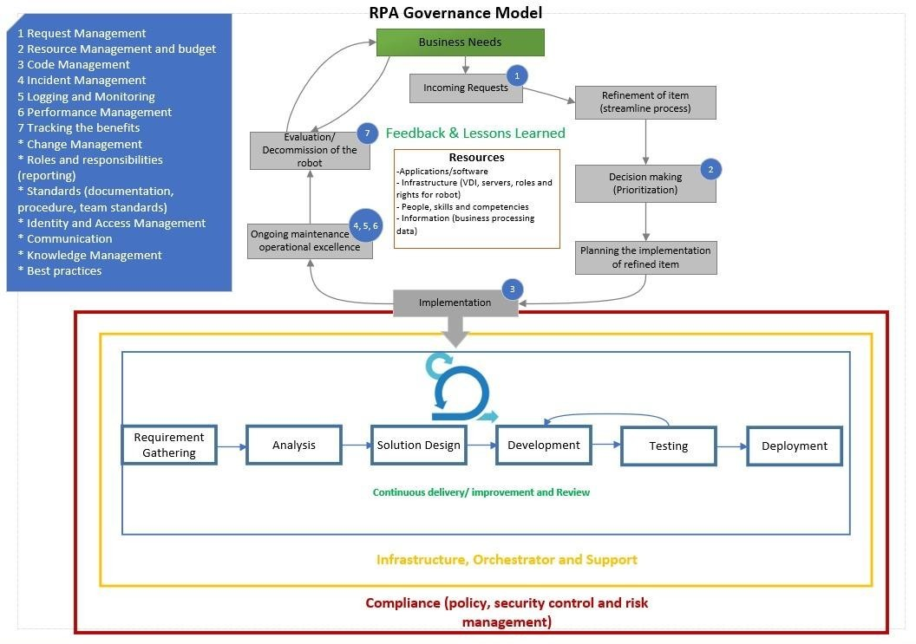

**4. Proposed Architecture**

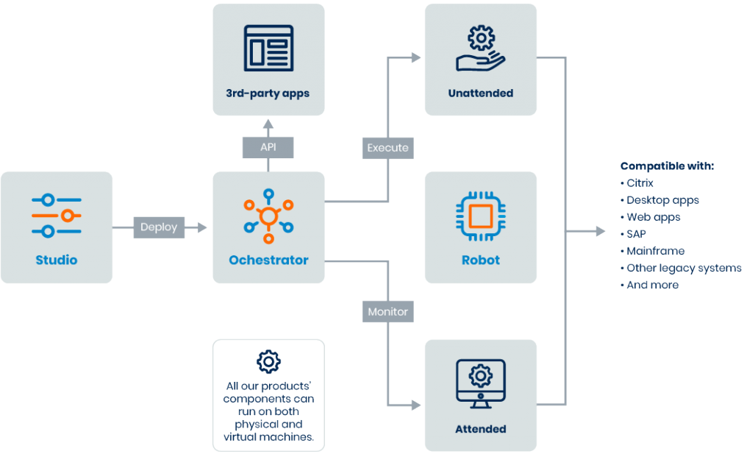

To make the integration with Noida Power Company Limited (NPCL) systems seamless, we propose the usage of Orchestrator for not only scheduling the robots but also to use it as an integration platform.

**5. UiPath Products**

Netlink proposes to use UiPath Technology stack to deliver this automation project of Noida Power Company Limited (NPCL). Below are the various UiPath components that are required to be licensed for smoother delivery of this project.

**UiPath Studio:** UiPath Studio allows RPA developers to create workflows, with API integrations to an ever-growing list of applications, technologies, and platforms. More complex automations are easily handled with basic coding knowledge.

Users: RPA Developer, Business Decision Maker, Business User

**UiPath Orchestrator:** Orchestrator Deploys, manages and optimizes your Robots with enterprise-scale integrations and compliance.

Users: RPA Developer, IT Admin, CoE Admin

**UiPath Robot:** Run automations with software robots that are intelligent, flexible, and eager to take on tedious tasks.

Users: CoE Lead, Business Decision Maker, Technical Decision Maker, RPA Developer, Automation User

**UiPath Action Center:** When an automation includes decisions that a person should make—like approvals, escalations, and exceptions—UiPath Action Center makes it easy and efficient to hand off the process from robot to person. And back again.

Users: Business Decision Maker, Technical Decision Maker, Automation User

**UiPath Document Understanding:** To extract, interpret, and process data for you, even from PDFs, images, handwriting, and scans? UiPath Document Understanding helps your robots do just that. Delegate more of your digital paperwork with a boost from AI.

Users: Technical Decision Maker, RPA Developer, Automation User

**6. Delivery Methodology & Approach**

Netlink will use a hybrid development methodology using Waterfall during Requirements gathering phase and Agile in design and development phases.

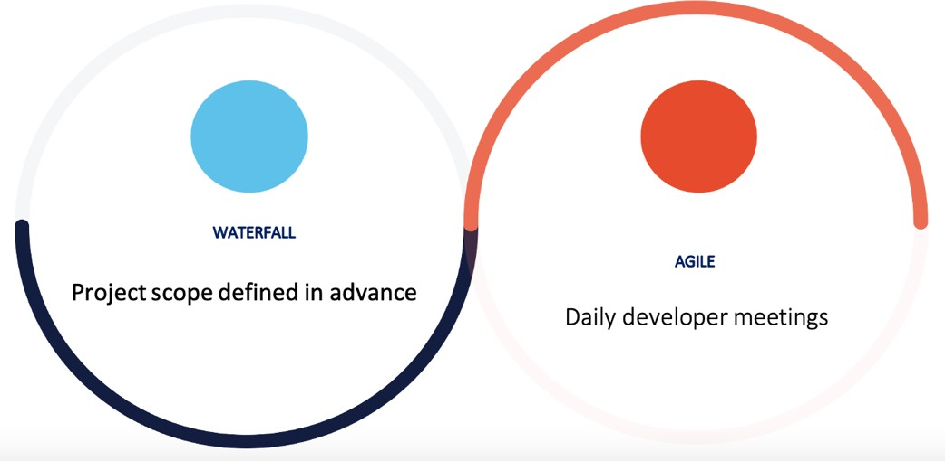

**Automation Implementation Methodology**

|  |  |  |  |
| --- | --- | --- | --- |
| **Stage** | **Role Involved** | **Key Task** | **Output** |
| **Kick Off** | •Solution Architect | •Set up the overall expectations of the project | • Reviewing the SOW |
| • Project Manager | • Early RPA readiness discussions about: | • Setting upcommunicationcadence |
| • Infrastructure Engineer | − Client’s environment and infrastructure | • Completing the customer readiness checklist |
|  | − Test and dev environments | • Initiating the Issue Tracker |
|  | − Test data/test cases |  |
| **Process Analyze** | •Solution Architect | • Analyze the chosen process in its as-is state and start the PDD | • Defining and finalizing the “to-be” process |
| • Project Manager | • Identify the degree of automation | • Completing and approving the PDD |
| • Business Analyst | • Streamline the business flow to the ‘to-be’ process | • Creating and approving the UAT plan |
|  | • Fill the PDD with the as-is and to-be processes |  |
| **Solution Design** | • Business Analyst | • Design a future state flow and maps out modules for automation development | • Completing the SDD document |
| • Solution Architect | • Use Application Tracker to record access required by the developer to build and run automation UAT and Production | • Completing the Application Tracker |
| • Project Manager | • Prepare the Technical Testing plan encompassing UAT scenarios, functional testing, and system integration testing | • Completing the Technical Testing Plan |
| • Automation Developers |  |  |
| **Development & Testing** | • Solution Architect | • Create the modules outlined in the design whiteboard using the PDD and SDD | • Building automation |
| • Project Manager | • Review and make necessary changes to the code | • Completing Unit and Integration Testing |
| • Automation Developers | • Test and run the modules individually in controlled settings | • Completing code review |
|  | • Execute the Technical Testing plan after Development and Unit Testing | • Executing Technical Testing plan |
|  | • Create automated tests for functional testing to confirm large functions independently |  |
|  | • Complete end-to-end test for system integration testing |  |
|  | • Run all UAT test scenarios |  |
| **User Acceptance Testing (UAT)** | • Business Analyst | • Conduct UAT in coordination with the implementation team | • Executing UAT Test Cases |
| • Solution Architect | • Run all the potential happy path and business exception scenarios | • Signing off client business team test execution |
| • Project Manager | • Ensure all agreed-upon scenarios are tested | • Completing the Run book document |
| • Automation Developers | • Log any deviations and fix that with the help of the Automation Team |  |
|  | • Create a Runbook document template with the following details: |  |
|  | − System architecture |  |
|  | − Production environments |  |
|  | − Operating instructions for automation |  |
|  | − Instructions to the operations, IT, and automation implementation team |  |
|  | • Document the Runbook template for every automation |  |
| **Deployment and Hypercare** | • Solution Architect | • Migrate the final process packages, libraries, and assets to the production Orchestrator | • Revising the Runbook document |
| • Project Manager | • Identify and address issues quickly using hypercare | • Completing production bug fixes |
| • Automation Developers | • Run and review production cases using hypercare |  |
|  | • Fix issues promptly and repush to production |  |
|  | • Initiate knowledge transfer during hypercare |  |
| **Project Closure** | • Business Analyst | • Confirm conformance of all services are made as per the contract | • Checking and signing off contract completion by the client |
| • Solution Architect | • Carry out the handover process for long-term support of the developed automations | • Initiating knowledge transfer and document handover |
| • Project Manager | • Check and close financial loops |  |
| • Automation Developers |  |  |
| • Business Team |  |  |

**Development Approach:**

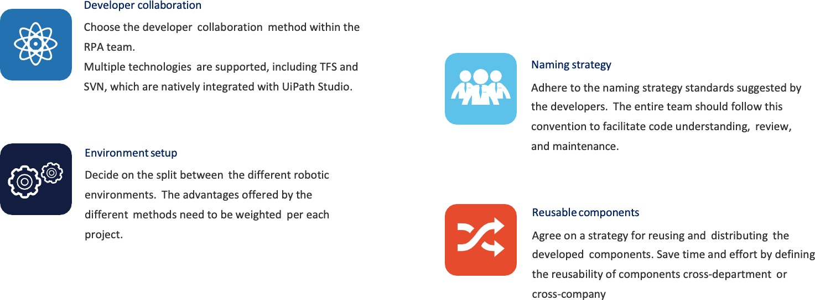

**7. Scope of Work**

Netlink understood the Noida Power Company Limited (NPCL) IT landscape mentioned in the RFP and concluded the scope of work as below:

• Unattended Bot development addressing all the requirements of the project in scope

• Completion of the project, with the details of the project being implemented for the respective scenarios

• Source Code handover

• Execution Log Report as Output file

• Knowledge Transfer on the completed process

• Report contains the metrics of the duration of BOT execution time.

• Number of tasks completed by a BOT.

• BOT pass / failed status.

• Complete report on BOT on daily basis

Below are the in scope processes for automation:

• Recharge Coupon Generation (Prepaid Meter)

• MRO Creation & ZMR Match

• Procure-to-Pay process in SAP

• ZMTDETAILS & EL16 Process for Billing

**A. Recharge Coupon Generation (Prepaid Meter)**

**Overview:** Email containing an attached Excel file for prepaid consumer meters that require recharging. A designated team member will extract data from the source Excel file and format it according to the CSV template for uploading. After successfully uploading the file & log in to the SAP GUI and enter the T code (IQ02), following the steps outlined in the diagram below.

This process involves utilizing three data sources: Excel, a Secure Portal, and SAP GUI. It is used to generate recharge coupons for prepaid meters in various scenarios, such as new connections and meter replacements (including load augmentation and load reduction)

**Bot Flowchart Diagram**:

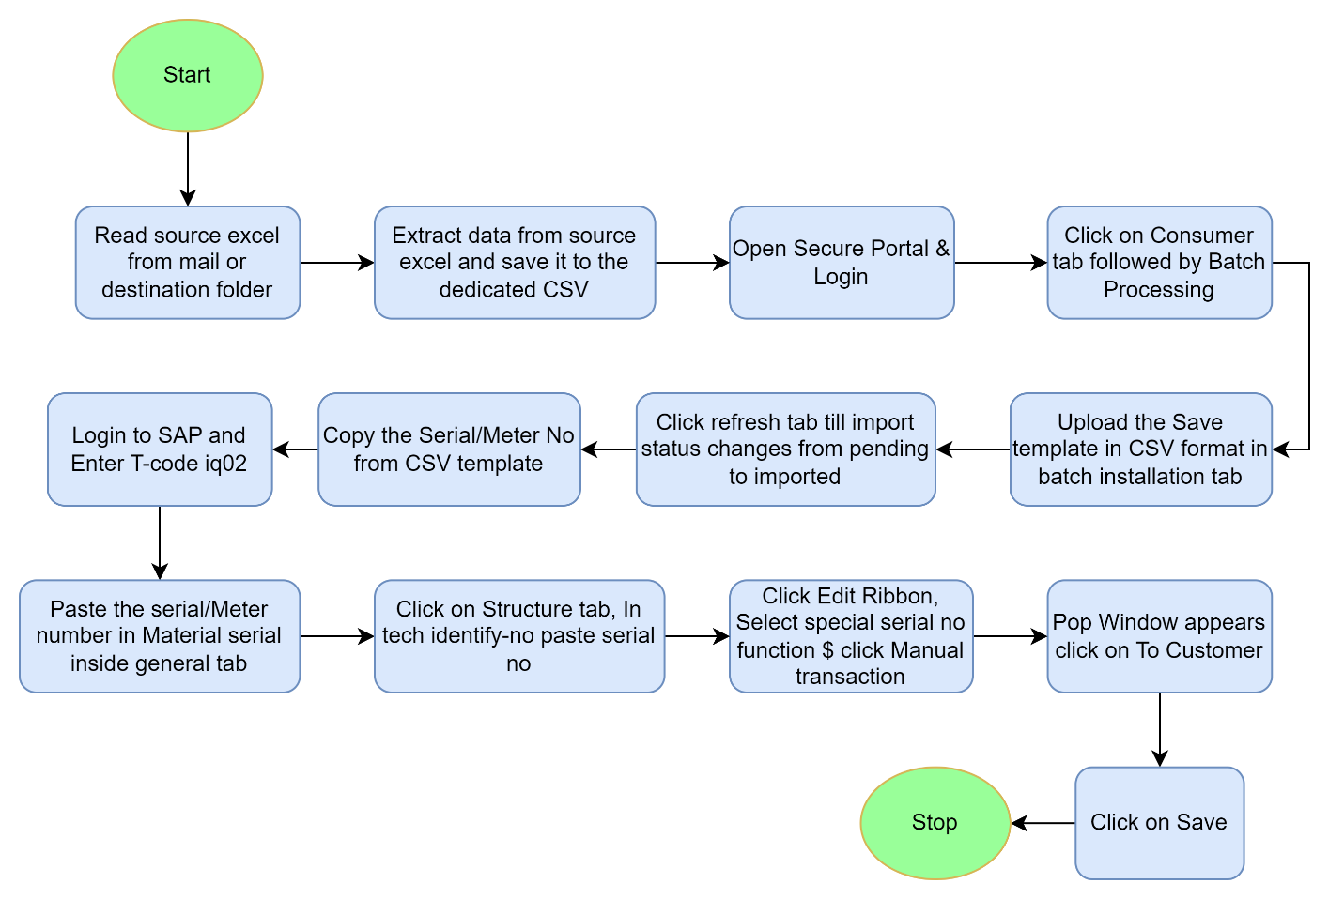

**DETAILED PROCESS FLOW:**

The points listed below give you a chronological overview of the actions that the robot should perform upon execution of the project:

Step 1- Robot will read source excel from mail or destination folder

Step 2- Extract data from source excel and save it to the dedicated CSV

Step 3- Open Secure Portal & Login with credentials.

Step 4- Click on Consumer tab followed by Batch Processing and Upload the Save template in CSV format in batch installation tab.

Step 5- Click refresh tab till import status changes from pending to imported.

Step 6- Copy the Serial/Meter No from CSV template.

Step 7- Login to SAP and Enter T-code iq02, Pop Window appears click on To Customer.

Step 8- Click Edit Ribbon, Select special serial no function $ click Manual transaction

Step 9- Click on Structure tab, in tech identify-no paste serial no

Step 10- Paste the serial/Meter number in Material serial inside general tab

Step 11- Click on Save and stop the process

**Process Success Output:**

Robot will generate recharge coupons for prepaid meters in various scenarios, such as new connections and meter replacements (including load augmentation and load reduction).

**B. MRO Creation & ZMR Match:**

**Overview:** In Order to get the timely reading and billing in every month, Consumers numbers are tagged with MRU & Portion as per their meter type. Every MRU & Portion has date wise meter reading schedule. To get timely reading and billing, Meter Reading Order (MRO) is created portion wise of every portion in beginning for every month as per the Reading schedule.

**Bot Flowchart Diagram:**

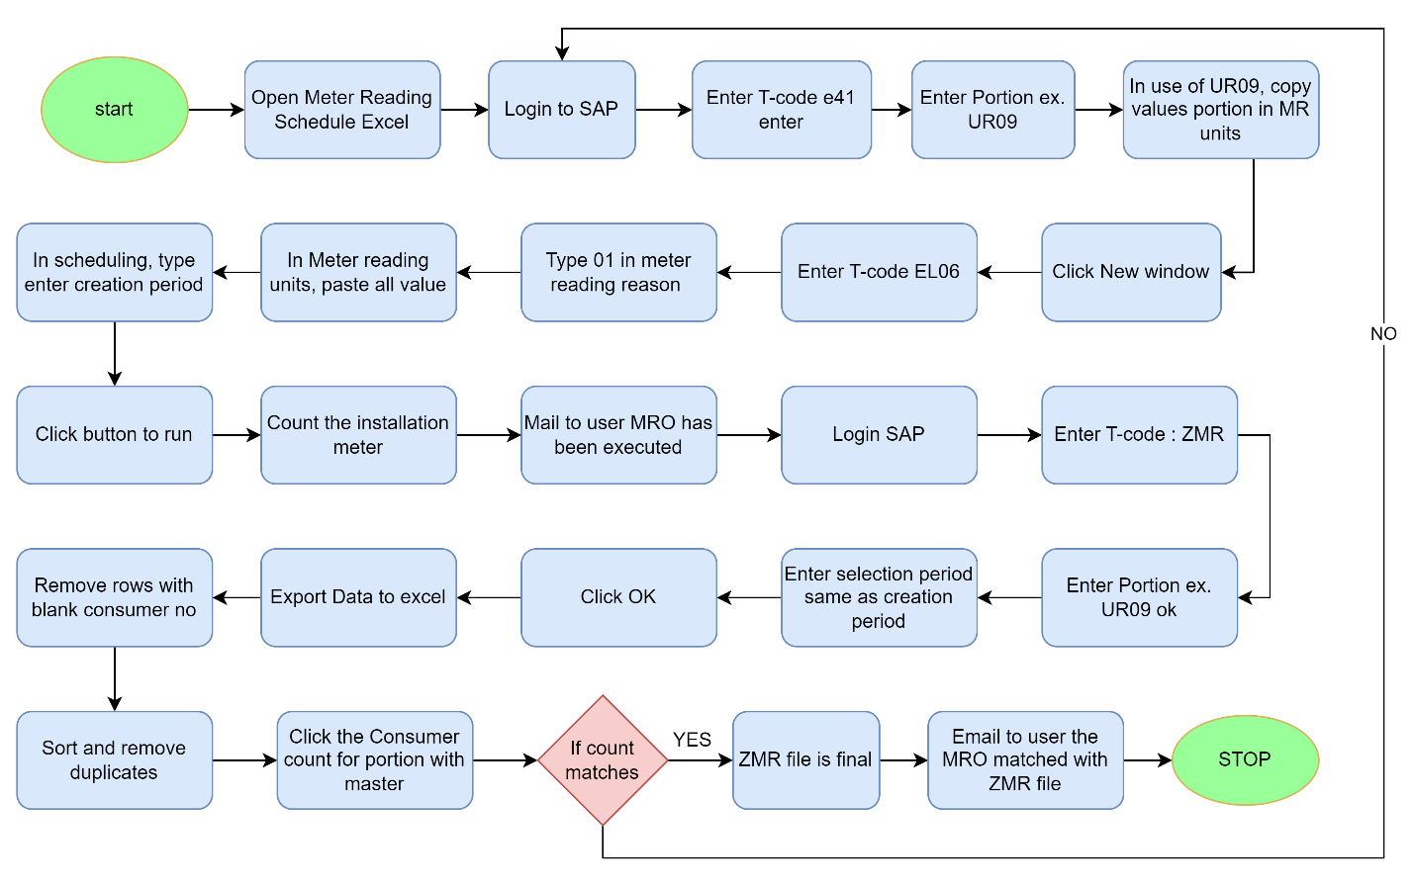

**Detailed Process Flow:**

The points listed below give you a chronological overview of the actions that the robot should perform upon execution of the project:

Step 1: Robot will Open Meter Reading Schedule Excel

Step 2: Login to SAP with valid credentials and Enter T-code e41 enter

Step 3: Enter Portion ex. UR09. In use of UR09, copy values portion in MR units and Click New window

Step 4: Enter T-code EL06 and Type 01 in meter reading reason

Step 5: In Meter reading units, paste all value

Step 6: In scheduling, type enter creation period and Click button to run

Step 7: Count the installation meter and Mail to user MRO has been executed

Step 8: Login SAP with valid credentials, Enter T-code: ZMR

Step 9: Enter Portion ex. UR09 ok, Enter selection period same as creation period and Click OK

Step 10: Export Data to excel, Remove rows with blank consumer no, Sort and remove duplicates and click the Consumer count for portion with master

Step 11: If count matches then ZMR file is final. Email to user the MRO matched with ZMR file.

Step 12: If count does not match repeat the process from step 2.

Step 13: Stop the process.

**Process Success Output:**

Robot will create Meter Reading Order (MRO) of every portion in beginning for every month as per the Reading schedule.

**C. Procure-to-Pay process in SAP**

**Overview:** The Procure-to-Pay (PR to PO) process in SAP encompasses the seamless flow of activities involved in procurement until the creation of a purchase order (PO). It begins with the initiation of a purchase requisition (PR) when a department identifies the need for goods or services. This PR undergoes approval processes before being converted into a purchase order. The PO details the specific items, quantities, and terms agreed upon, providing a formal document for the vendor. This process ensures that procurement follows a structured path, enabling effective tracking and control over the acquisition of goods and services within the SAP environment.

**Bot Flowchart Diagram:**

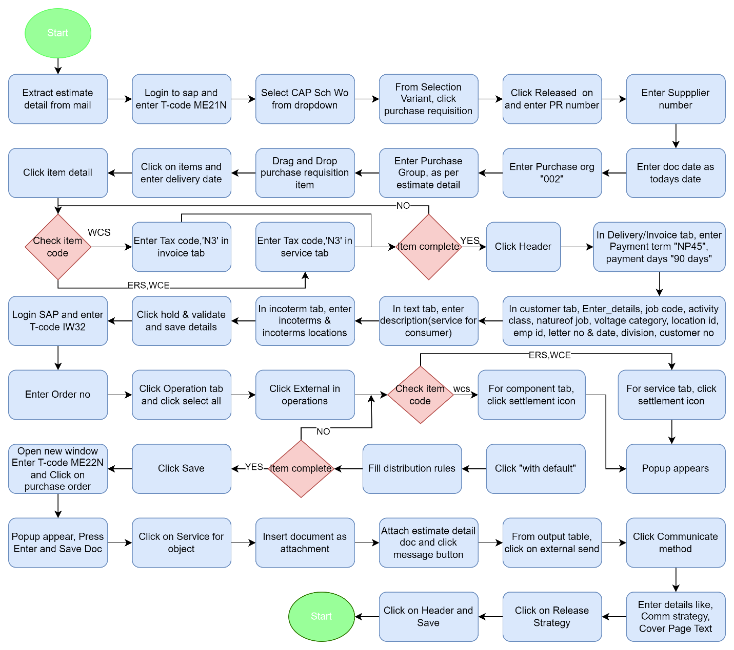

**Detailed Process Flow:**

The points listed below give you a chronological overview of the actions that the robot should perform upon execution of the project:

Step 1: Robot will Extract estimate detail from mail.

Step 2: Login to SAP and enter T-code ME21N.

Step 3: Select CAP Sch Wo from dropdown, from Selection Variant, click purchase requisition.

Step 4: Click Released on and enter PR number, Enter Supplier number, Enter doc date as todays date, Enter Purchase org "002",Enter Purchase Group, as per estimate detail.

Step 5: Drag and Drop purchase requisition item, Click on items and enter delivery date.

Step 6: Click item detail and check item code, if item code is WCS then Enter Tax code,'N3' in invoice tab and if item code is ERS,WCE then Enter Tax code,'N3' in service tab.

Step 7: Check item completed or not, if yes then click header else repeat Step 7.

Step 8: In Delivery/Invoice tab, enter Payment term "NP45", payment days "90 days".

Step 9: In customer tab, Enter details, job code, activity class, nature of job, voltage category, location id, emp id, letter no & date, division, customer no.

Step 10: In text tab, enter description (service for consumer).

Step 11: In incoterm tab, enter incoterms & incoterms locations.

Step 12: Click hold & validate and save details.

Step 13: Login SAP and enter T-code IW32, Enter Order no and Click Operation tab and click select all.

Step 14: Click External in operations and check item code, if item code is WCS then click settlement icon for component tab and if item code is ERS, WCE click settlement icon for service tab.

Step 15: Popup appears, Click "with default" and fill distribution rules.

Step 16: Check item completed or not, if yes click save else repeat from Step 15.

Step 17: Open new window Enter T-code ME22N and Click on purchase order.

Step 18: Popup appear, Press Enter and Save Doc.

Step 19: Click on Service for object, Insert document as attachment, Attach estimate detail doc and click message button.

Step 20: From output table, click on external send, Click Communicate method. Enter details like, Comm strategy, Cover Page Text and Click on Release Strategy.

Step 21: Click on Header and Save. Stop the Process.

**Process Success Output:**

Robot will create purchase requisition (PR) when a department identifies the need for goods or services. This PR undergoes approval processes before being converted into a purchase order. The PO details the specific items, quantities, and terms agreed upon, providing a formal document for the vendor.

**D. ZMTDETAILS & EL16 Process for Billing**

**Overview:** All the meters are tagged with MRU as per their meter type (BLE/LPR/AMR/GROUP). To identify the meter type in MRO/ZMR, ZMTDETAILS report is exported and details is updated in master ZMU and emailed to the user that they can proceed for meter reading. All single-phase meters are read through mobile application. To allocate the data of single -phase meters in mobile application as per the schedule, EL16 T-code is executed in SAP.

**Bot Flowchart Diagram:**

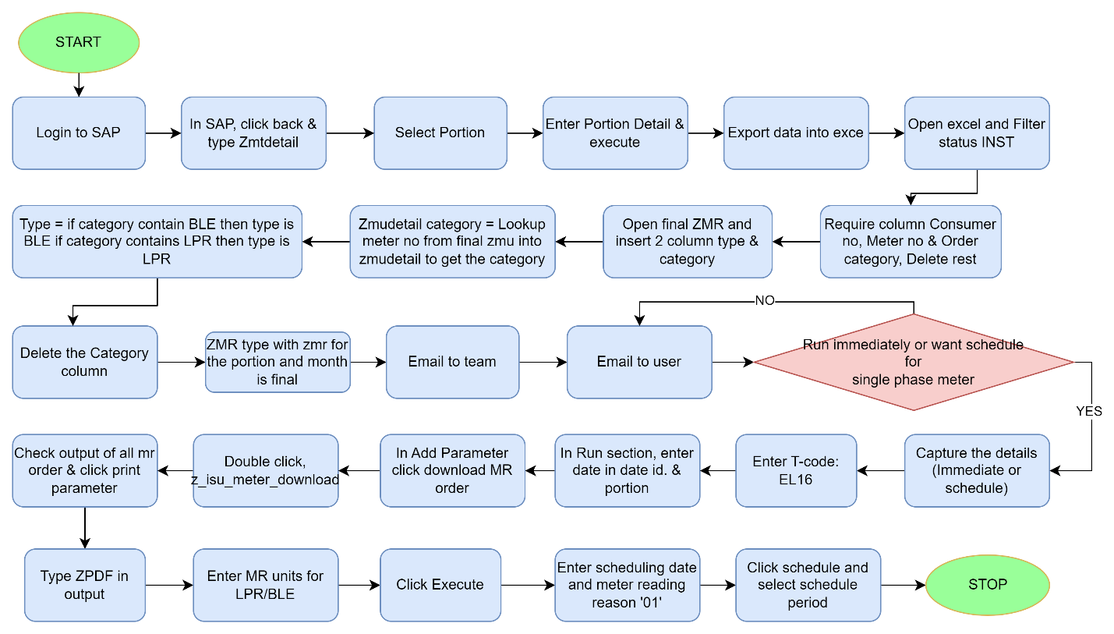

**Detailed Process Flow:**

The points listed below give you a chronological overview of the actions that the robot should perform upon execution of the project:

Step 1: Robot will Login to SAP and In SAP, click back & type Zmtdetail.

Step 2: Select Portion and enter Portion Detail & Execute.

Step 3: Export data into excel, open excel and filter status INST. Require column Consumer no, Meter no & Order category, Delete rest.

Step 4: Open final ZMR and insert 2 column type & category.

Step 5: Category = Lookup meter no from final zmu into zmudetail to get the category.

Step 6: Type = if category contain BLE then type is BLE if category contains LPR then type is LPR.

Step 7: Delete the Category column, ZMR type with zmr for the portion and month is final.

Step 8: Email to team and user.

Step 9: Apply Condition Run immediately or want schedule, if no send mail to user.

Step 10: If yes then capture the details (Immediate or schedule). Enter T-code: EL16

Step 11: In Run section, enter date in date id. & portion.

Step 12: In Add Parameter click download MR order and Double click, z_isu_meter_download.

Step 13: Check output of all MR order & click print parameter and type ZPDF in output.

Step 14: Enter MR units for LPR/BLE and click execute.

Step 15: Enter scheduling date and meter reading reason '01'.

Step 16: Click schedule and select schedule period. Stop the process.

**Process Output:**

Robot will identify the meter type in MRO/ZMR, ZMTDETAILS report is exported and details is updated in master ZMU and emailed to the user that they can proceed for meter reading. Robot will execute EL16 T-code is executed in SAP to allocate the data of single -phase meters in mobile application as per the schedule.

**Efforts Estimation for RPA:**

Before starting the automation, NPCL will have to provide the infrastructure needed to setup UiPath’s platform as this is an On-Premise installation. The requirements of these details can be found on <https://docs.uipath.com/automation-suite/automation-suite/2023.4/installation-guide/single-node-evaluation-profile-requirements-and-installation>  
  
It will take 2-3 weeks for Netlink to set up the UiPath infrastructure.

|  |  |
| --- | --- |
| **Tasks** | **Client Name- NPCL Automation** |
|
| Requirements Gathering | 24 hours |
| Design/Creation of Solution design document | 24 hours |
| Development and Parallel testing | 4 weeks |
| UAT & Move to Production deployment | 1 weeks |
| Hyper care/Support | 2 weeks |
| **Total** | **328 hours** |
| **Total Efforts** | **8 Weeks** |

**Project Schedule / Timelines**

|  |  |  |  |  |  |  |  |  |  |
| --- | --- | --- | --- | --- | --- | --- | --- | --- | --- |
| **Delivery Phases** | Progress | WEEK 1 | WEEK 2 | WEEK 3 | WEEK 4 | WEEK 5 | WEEK 6 | WEEK 7 | WEEK 8 |
| **Requirement Gathering** | 10% |  |  |  |  |  |  |  |  |
| **Technical Design** | 20% |  |  |  |  |  |  |  |  |
| **Development** | 70% |  |  |  |  |  |  |  |  |
| **Testing** | 85% |  |  |  |  |  |  |  |  |
| **UAT & Production Deployment** | 100% |  |  |  |  |  |  |  |  |
| **Hypercare** | 100% |  |  |  |  |  |  |  |  |

**Criteria for considering the development done for a process:**

1. Code produced (completed all ‘To-do’ items in code)

2. Code commented according to best practices, checked and ran against current version in source control

3. Peer reviewed (or produced with pair programming) and meeting development standards

4. Passed unit tests

5. Deployed to system test environment

6. Passed System Integration tests and signed off as meeting requirements

7. SDD document filled in and approved

8. Relevant documentation/diagrams produced and/or updated

**Proposed Team structure**

The role constitution for the Automation is mentioned below:

|  |  |  |
| --- | --- | --- |
| **Role** | | |
| Project Manager | Technical Solution Architect | Automation Developer |
| Process Owner | Business Analyst |  |

**Assumptions:**

Netlink would like to anticipate the following assumptions for the project:

Automation will be deployed On-premises and infrastructure will be provided by NPCL before starting the automation.

Stable Internet – Netlink assumes users have reliable internet for system access.

Training Support – Netlink assumes adequate training is provided for a smooth transition.

**8. Support**

This section describes in detail the support process that would be adopted by Netlink for fulfilling the in-scope requirements. The details requested in the RFP have been provided in the following paragraphs.

Hours of Operation

Unless called out otherwise, Netlink will provide the requisite support to meet Client’s requirements during the business hours specified below:

• Regular Support: Monday to Friday, 8 a.m. to 5 p.m. Local Time, excluding holidays

• Emergency Support: 24 x 7 x 365

• 24 x 7 Service Desk to receive and route Client’s L2 support needs via:

E-mail

Phone

Self-service portal

**Average and Guaranteed Response Time**

Netlink’s issue/ incident classification model ensures timely response to service requests. This model is based on the following evaluation criteria:

|  |  |
| --- | --- |
| Criteria | Severity Level |
| Critical – The IT function affected is unavailable and is required for the  primary business operations of Client or its end-customers | Severity 1 |
| Serious – The IT function affected is not fully available and is required for the  business operations of Client or its end-customers | Severity 2 |
| Other – The IT function affected does not impact business operations, but is  included in the scope of services provided by Netlink | Severity 3 |

|  |  |
| --- | --- |
| Prioritization Criteria for Request | Priority Code |
| Funded by Client’s end-customers or Change requested by business critical  Functions | Priority 1 |
| Potential for additional business (Client initiated)  Business unit committed to pay for change that is customer facing | Priority 2 |
| All other scenarios | Priority 3 |

**9. Training Process**

This section describes in detail Netlink’s training process.

**Guiding Training Philosophy**

· Train the Trainer approach is included for training.

· Train the Trainer scope will be limited to Oracle Fusion to deliver the in-scope functionality to Client.

· Netlink will provide the required knowledge and process expertise to Client by means of “Train the Trainer” approach conducted by the respective Functional Leads.

**Identification of Client Training Gaps/Needs**

Netlink will start to identify the training gaps / needs right from the project kick-off stage by:

• Reviewing existing training documents and processes

• Conducting key business user interviews to identify deviation from standard operating procedures

• Auditing recent ticket history to identify areas for training needs

**Forms/Methods of Training Utilized**

· Workshops

· Virtual / Webinars

· Audio / Video/ Organizational Process Assets & Training Material

**Availability of Trainers / Training Material**

· Trainers will be available as per the schedule that Netlink and Noida Power Company Limited (NPCL) agree to.

· A training calendar will be published periodically as per the identified training needs.

· Netlink proposes a dedicated space for Organizational Process Assets where the knowledge base will be stored with documents like:

o Graphical Business Process Procedures and job aids

o Business scenarios as applicable to current existing process used at Noida Power Company Limited (NPCL) along with working instructions

**Updates to Training Materials**

Training materials will be updated by the respective trainers/ functional experts in the following scenarios:

• Any new change implementation

• Any issue identified in current process is resolved